County of Fairfax, Virginia

To protect and enrich the quality of life for the people, neighborhoods and diverse communities of Fairfax County

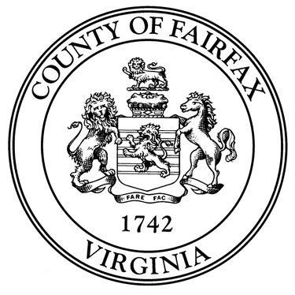

Dear Prospective Parent,

Thank you very much for your interest in providing a permanent home and family to a child featured on Fairfax County’s website <https://www.fairfaxcounty.gov/familyservices/children-youth/foster-care-adoption/children>. Please follow the next steps so that we may guide you in this process:

1. If you want to learn more about a child, please complete the “Information Request Form” so that your inquiry reaches the Permanency Coordinator looking to match the child with a family.
2. Once you have completed the Information Request Form, please contact Dr. Patricia Aviles-Cubillos, foster parent recruiter for our program. She can be reached at 703-324-7919 or by email at [patricia.aviles-cubillos@fairfaxcounty.gov](mailto:patricia.aviles-cubillos@fairfaxcounty.gov)
3. Provide Dr. Cubillos:

* Your personal contact information:
  + - Full name
    - Address
    - Phone number
    - Email.
    - Please indicate your preferred form of communication.
* The name of the child you identified on our website.

1. Once Dr. Cubillos receives your information, she will:

* Connect you with the Permanency Coordinators currently searching to match a family with the child you identified.
* One of the Permanency Coordinators will contact you. The Permanency Coordinator will ask some preliminary questions about your family in order to assess if you could be a match for the child.
* This initial phone call also provides you the opportunity to ask any questions you may have about the child.

1. If the permanency coordinator and your family mutually agree to move forward with the process, the coordinator will request an *“Initial Home Visit.”*

* Dr. Cubillos will conduct the Initial Home Visit and will explore further if your family and the child could be a potential match.

1. Dr. Cubillos will contact you to provide feedback and information about next steps.

*Fairfax County is committed to nondiscrimination on the basis of disability in all county programs, services and activities. Reasonable accommodations will be provided upon request. 703-324-7639 / TTY 703-222-9452.*

Fairfax County is committed to nondiscrimination on the basis of disability in all county programs, services and activities. Reasonable accommodations will be provided upon request.